Design Document
This is a design document for BubbleWrapped Dynamite v1.0.

Designer: Barry Breen

Introduction
This is a rest service in java that is a work order request management system. Work Order requests are submitted through endpoints provided.

Technologies
- Apache Tomcat v7
- Maven
- Jersey v1.19.1 (Restful Interface)
- Mokito (Junit Testing)

Build
To Build the project, navigate to the top-level directory in the repository and open a command line.

To build projet with tests:
mvn clean install

to build without running tests:
mvn clean install -DskipTests

Maven will builid the project by:
a) clean the project by deleting the target directory
b) recreate the target directory with all the files and the war file.

Mvn builds the WAR to: %directory_path% / target

Maven directory where WAR is created
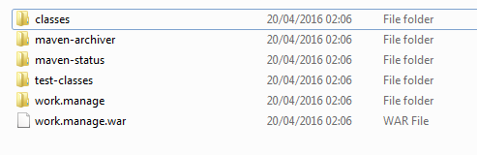

Build output in Maven
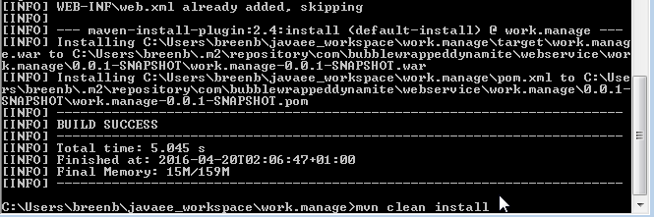

Deployment
The web service will be deployed using Apache Tomcat. Tomcat will host the WAR file.
To Deploy:

- Drop the WAR build from Maven into your Tomcat Directory webapps folder
- From command line, navigate to tomcat directory / bin
- Execute startup.bat (Windows)

Startup.bat being executed in windows Command Prompt
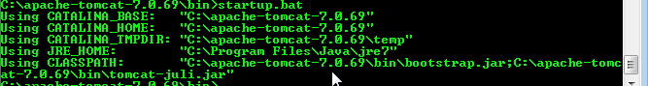

Testing
This application is tested using the rest service endpoints provided. All endpoints are not implemented due to time constraints on understanding other concepts of the web service.
To Test:
- Install Postman extension in google chrome or download a similar postman client
- Select your Request Type (POST / GET) and enter the url for the webservice endpoints

To Test the service is up:
URL: http://localhost:8080/work.manage/bubblewrappeddynamite/Endpoints/Test/
Request Type: @GET
Return: OK Status 200
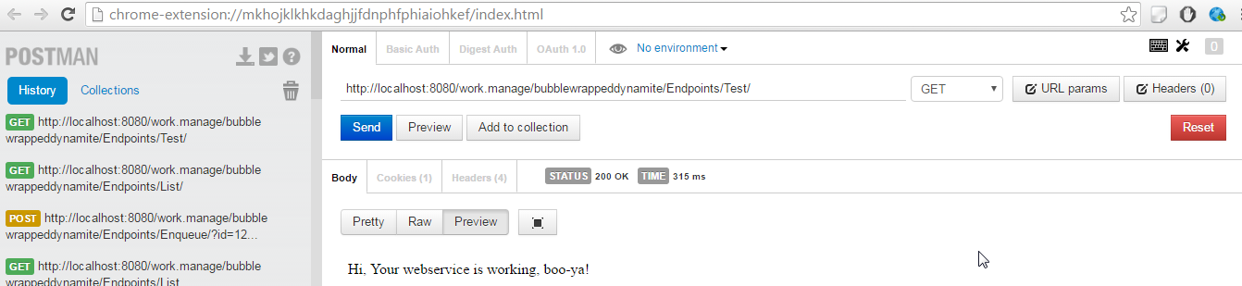

To Add a work order item to the Queue:
URL: http://localhost:8080/work.manage/bubblewrappeddynamite/Endpoints/Enqueue?id=108 & time = 180600
Request Type: @POST
Return created: Status 201

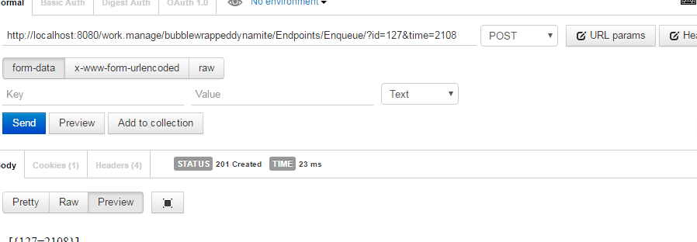

Limitations
Due to current work commitments that need closing off, and inaccurate time allocation this project is not complete.
I have attempted to show all parts of the project working Testing, Unit tests, maven and deployment and the web service how it works.
I personally got caught as I was knew to Java EE and web services and the Rest Statelessness hindered my development to keep the state of a work order request so a database would have been required as making the service stateful would have breach the basic principles of the web service and contradict the ideology of a web service and best practices.

